Project Title: Design and Implementation of E-Learning Web Platform

Supervisor’s Name: Rasha lBrahim

Student Name: Yao

**Project Aim**:

The main goal of this project is to design and build an online learning platform.

The main users of the platform are：

students who want to review the content of the classroom,

students who want to learn the extended content,

and even individuals who do not have the opportunity to go to high school or college.

The main purpose of the platform is to make learning an autonomous process,：students will not be interrupted by the relentless class time when they are studying problems at classroom. And the goal of this system is to help students deepen their understanding by accessing learning content and lectures anytime them want. This system allows students to study no longer just for exams, but through the connection and recommendation of knowledge, there can be more organic connection between the content for students. With the assistance of our system, students have the freedom of time from classroom, and they are guided by their own curiosity and follow the path of interest, because the recommendation part of the system and the knowledge map can better connect the learning content.

**Project Objectives**:

The E-Learning system functions currently consist of the following:

1. User registration/login/

Users can register according to email/phone/username, etc., can have nickname, password

2. Personal homepage

Users can have their own personal profile, and the profile can modify the information of various first steps

3. Permission division (administrator/common user)

Administrators can see the course list, add, delete, modify and check courses

4. The introduction page of the course (title, content)

5. Course related training video upload function, video download function

6. The video playback function of the course (need to integrate a streaming media player, and html5 player)

7. The home page of the website displays the course, go to registration, login, personal homepage, various places

8. Some advanced functions, such as the information of the E-learning whole station course, do the knowledge graph function (analysis, knowledge graph association and visualization)

9. Recommendation system (using collaborative filtering recommendation algorithm based on offline data of other users, recommending courses that users may be interested in/should learn)

**Description**:

The current educational system divides knowledge into disciplines and further divides disciplines into separate units. There is a potential risk in this division, which creates the illusion that each point of knowledge is scattered and unrelated. This is a very serious problem, but a more fundamental problem is that the knowledge points may not be fully covered, this is because the school decides the learning progress according to the learning time of each knowledge point, not according to the mastery of each student degree to arrange the study plan. After finishing a knowledge point according to the allotted time, the teacher will quiz the students and start to move on to the next knowledge.

（Reference1 of teaching Reform at West Chester University of Pennsylvania ：<http://xxh.resource.edu.cn/news/935.html>

Reference2 of students have access to online documents, discussions and learning increase vitality https://www.ncbi.nlm.nih.gov/pmc/articles/PMC7976733/

）

Now Machine Learning and Data analysis has developed and used in Commercial websites such as Twitter/Facebook. Today's learners are faced with a huge amount of learning materials, information overload and the quality of learning materials is not easy to know.

In this environment, learners face the problems of "information overload". Personalized recommendation system is an effective way to solve "information overload". The recommendation system mines the learner's potential interest preference according to the learner's historical behavior, calculates the similarity between the learner and the resource, and recommends the teaching resources that may be of interest to the learner.

The learning process of learners has the characteristics of gradual progress and knowledge from shallow to deep. There are rich logical relationships between the knowledge points contained in the teaching resources. Therefore, it is necessary to consider the relationship between the knowledge points.

Our system composition has considered recommendation algorithms and knowledge graphs, making them guides for learners.

From a practical point of view, our traditional classroom teaching model does not have sufficient conditions to provide each student with targeted review and make-up exams, nor does it allow students to get rid of rote learning methods and understand through open and creative ways Knowledge.

I've always felt that with the help of online video courses that are self-paced by students, already interactive and assisted by big data, coupled with computer feedback and the help of a team of teachers, students only need to spend 1-2 hours a day on basic courses, but they are free hours to work on individual or group innovative projects, such as writing poetry, writing computer code, making movies, building robots, painting, or conducting small experiments related to physics or mathematics

**Initial areas of research**:

Initially, I plan to build the main framework of the website(flask/bootstrap/vue/Sqlchemy),including video uploading and downloading of online courses, as well as user registration and login systems. I think this is the initial basic function.图像

Follow-up advanced features: recommendation system and knowledge graph system, I will add it later

**Expected outcomes**: A real system that is usable and practical to help review and learn related knowledge outside of the classroom. It can really help students, this is what I expected it to be.

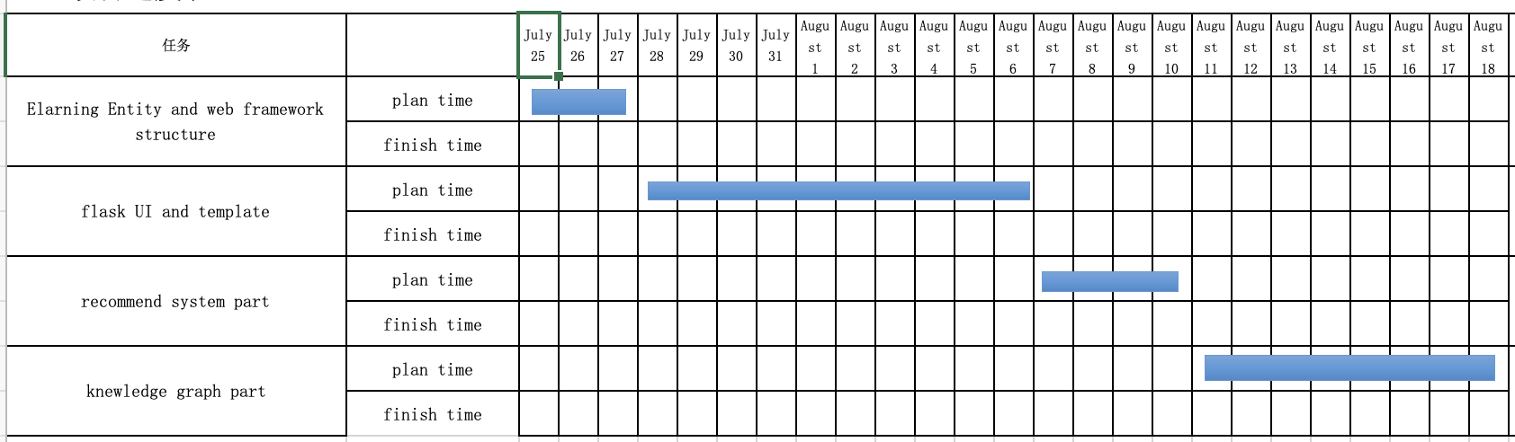**Project plan**:

Week 1: Build the main structure and permission system of the website

Week 2: Building the website's UI and template system

Week 3: Building Website Backend and Recommender System Components

Week 4: Building the Knowledge Graph Component of the Website